**THREE:**

**1) Extract movie reviews for any movie from IMDB and perform sentimental analysis**

**2) Extract anything you choose from the internet and do some research on how we extract using R**

**Programming and perform sentimental analysis.**

**Ans:**

> library(rvest)

> library(XML)

> library(magrittr)

> url <- "https://www.imdb.com/title/tt4154796/reviews?ref_=tt_urv"

> IMDB_avengers <- NULL

>for(i in 1:10){

murl <- read_html(as.character(paste(url,i,sep = "=")))

rev <- murl%>%

html_nodes(".show-more__control")%>%

html_text()

IMDB_avengers <- c(IMDB_avengers,rev)

}

> length(IMDB_avengers)

[1] 570

> length(unique(IMDB_avengers))

[1] 27

> IMDB_avengers[duplicated(IMDB_avengers)]

> write.table(unique(IMDB_avengers),"avengers.txt",row.names = F)

> Avengers <- readLines("avengers.txt")

**Cleaning unwanted https://..**

> df_avengers <- gsub(pattern = "http.*",replacement = "",x=Avengers)

> df_avengers <- gsub("https.*","",df_avengers)

> df_avengers <- gsub('\""','',df_avengers)

> library(textcat)

> table(textcat(df_avengers))

english norwegian scots ukrainian-koi8_r

37 2 5 1

> df_avengers[which(textcat(df_avengers)=="norwegian")]

> consider <- c(which(textcat(df_avengers)!="norwegian"))

> df_avengers <- df_avengers[consider]

> length(df_avengers)

[1] 43

**Text mining**

> library(tm)

> library(NLP)

> stopword <- readLines(file.choose())

> View(stopword)

> aveng_corp <- Corpus(VectorSource(df_avengers))

> aveng_corp <- tm_map(aveng_corp,removePunctuation)

**Removing stop words**

> aveng_corp <- tm_map(aveng_corp,removeWords,stopword)

> aveng_corp <- tm_map(aveng_corp,removeNumbers)

> aveng_corp <- tm_map(aveng_corp,stripWhitespace)

**Creating term document matrix**

> aveng_tdm <- TermDocumentMatrix(aveng_corp)

**Converting tdm to dtm**

> aveng_dtm <- t(aveng_tdm)

> rowtotal <- apply(aveng_dtm,1,sum)

> aveng_dtm2 <- aveng_dtm[rowtotal>3,]

> aveng_dtm2$dimnames$Terms

[1] "about" "abs" "absolute" "accept"

[5] "accomplish" "acting" "action" "actually"

[9] "after" "alerteven" "all" "already"

[13] "also" "amazing" "america" "and"

[17] "any" "are" "arrived" "arrow"

[21] "asgard" "avengers" "awhile" "back"

[25] "backim" "badass" "balance" "because"

[29] "been" "before" "behind" "best"

[33] "between" "big" "bring" "brothers"

[37] "but" "can" "capable" "captain"

[41] "careful" "cgi" "character" "characters"

[45] "clapping" "completely" "could" "cried"

[49] "crying" "dance" "depressed" "describe"

[53] "deserved" "did" "didnt" "disappointed"

[57] "dont" "duh" "emotion" "emotional"

[61] "emotions" "endgame" "ending" "enthusiasm"

[65] "epic" "even" "ever" "everything"

[69] "excitement" "expected" "experience" "face"

[73] "fat" "father" "felt" "fight"

[77] "finally" "finger" "for" "forever"

[81] "forget" "full" "fully" "get"

[85] "give" "gives" "god" "gonna"

[89] "goosebumps" "got" "great" "guy"

[93] "had" "happiness" "happy" "have"

[97] "havent" "hawkeye" "heart" "her"

[101] "herealso" "hero" "hes" "him"

[105] "his" "honest" "hours" "how"

[109] "infinity" "its" "jarvis" "joke"

[113] "joy" "just" "kill" "killed"

[117] "kinda" "know" "laughed" "laughing"

[121] "left" "lets" "life" "like"

[125] "line" "long" "loss" "love"

[129] "man" "many" "marathon" "marvel"

[133] "matter" "mean" "message" "met"

[137] "might" "miss" "missed" "moment"

[141] "more" "most" "movie" "movies"

[145] "much" "need" "not" "now"

[149] "outstanding" "own" "past" "peggy"

[153] "people" "perfect" "perfection" "performance"

[157] "person" "powerful" "pure" "quantum"

[161] "randomly" "reallife" "really" "realm"

[165] "remember" "responsible" "russo" "sadness"

[169] "sake" "save" "scene" "screaming"

[173] "seconds" "see" "self" "shape"

[177] "she" "shocked" "shot" "should"

[181] "showed" "slap" "snapping" "some"

[185] "speechless" "speechlessthis" "state" "still"

[189] "stomach" "story" "storytelling" "strong"

[193] "strongest" "stunning" "such" "superhero"

[197] "takesgo" "taking" "tears" "than"

[201] "thanos" "that" "thatspoiler" "the"

[205] "theater" "them" "there" "these"

[209] "they" "thinking" "this" "thisit"

[213] "thisready" "thor" "though" "thunder"

[217] "told" "tony" "too" "toowhen"

[221] "totally" "treat" "trying" "visually"

[225] "want" "war" "warm" "was"

[229] "watch" "watching" "way" "went"

[233] "what" "whatever" "when" "where"

[237] "whole" "why" "will" "win"

[241] "with" "world" "years" "you"

[245] "youll" "yourself" "abilities" "able"

[249] "actor" "add" "agree" "almost"

[253] "ancient" "annoying" "another" "anyone"

[257] "around" "balanced" "banners" "banteri"

[261] "barely" "beautifulthe" "better" "bit"

[265] "bizarre" "black" "brought" "buzz"

[269] "cant" "cap" "care" "cares"

[273] "change" "changing" "cinema" "clever"

[277] "convenient" "convenienti" "conversation" "couldnt"

[281] "created" "creates" "creating" "creeping"

[285] "cut" "day" "deal" "deaths"

[289] "defeat" "deus" "does" "doesnt"

[293] "easily" "elses" "elsethere" "end"

[297] "enjoyable" "enlightened" "entire" "erasing"

[301] "essentially" "everyone" "explain" "fan"

[305] "feel" "fingers" "first" "found"

[309] "franchise" "from" "game" "gamora"

[313] "gauntlet" "glaring" "goes" "gotg"

[317] "grief" "hand" "handedly" "happens"

[321] "hate" "hell" "here" "hilarious"

[325] "history" "hold" "hulk" "impossibly"

[329] "inconsistencies" "inevitably" "intentional" "into"

[333] "iron" "kills" "knowing" "lake"

[337] "loki" "loved" "machina" "made"

[341] "magically" "make" "meant" "meets"

[345] "mistake" "mjollnir" "naive" "never"

[349] "new" "nicely" "off" "okay"

[353] "one" "onethe" "original" "others"

[357] "out" "parallelsso" "particularly" "perhaps"

[361] "pfft" "plot" "present" "pretty"

[365] "prevent" "probably" "problem" "questions"

[369] "quill" "reaction" "real" "reallykilling"

[373] "references" "relationship" "renner" "reviews"

[377] "rich" "right" "said" "same"

[381] "say" "selfish" "send" "sent"

[385] "serious" "service" "show" "single"

[389] "sitting" "snaps" "someone" "spent"

[393] "stark" "started" "stay" "stick"

[397] "stones" "stop" "stormbringer" "stuck"

[401] "stuff" "stupid" "suddenly" "sure"

[405] "surprising" "swinging" "their" "theres"

[409] "theyre" "think" "thors" "thought"

[413] "through" "time" "timeline" "timelines"

[417] "times" "touch" "toy" "travel"

[421] "try" "unfortunatelythe" "universe" "universealso"

[425] "walking" "ways" "were" "while"

[429] "who" "widow" "without" "would"

[433] "wrap" "yet" "above" "anticipated"

[437] "appears" "areas" "aspects" "battle"

[441] "become" "beginning" "being" "biggest"

[445] "case" "center" "certain" "certainly"

[449] "cinematic" "clue" "comes" "comfortably"

[453] "comparison" "concern" "course" "critical"

[457] "details" "disappearedon" "disappointment" "discussed"

[461] "distress" "divided" "drags" "effects"

[465] "errors" "events" "everyones" "example"

[469] "expectation" "expecting" "familyof" "far"

[473] "fast" "film" "films" "final"

[477] "finale" "find" "fore" "forward"

[481] "front" "future" "general" "getting"

[485] "good" "happen" "has" "head"

[489] "heavy" "heroes" "higher" "highlights"

[493] "homage" "home" "important" "included"

[497] "insignificant" "last" "lee" "legend"

[501] "logic" "makes" "marvels" "meaningful"

[505] "meaningless" "means" "minutes" "moreover"

[509] "moves" "necessary" "normally" "only"

[513] "other" "our" "outside" "overshadowed"

[517] "packed" "partsavengers" "period" "play"

[521] "pointlastly" "predicament" "probability" "put"

[525] "realize" "recent" "related" "rest"

[529] "rising" "role" "scenes" "separate"

[533] "shouldnt" "slight" "slower" "small"

[537] "spiderman" "stage" "stan" "stories"

[541] "struggle" "successful" "surprise" "team"

[545] "tempo" "tenyear" "terms" "then"

[549] "theories" "threehour" "turn" "two"

[553] "undoubtedly" "visual" "waited" "wonder"

[557] "wondered" "youre" "avoid" "free"

[561] "going" "spoiler" "spoilers" "anything"

[569] "crowd" "crowds" "during" "dutch"

[573] "hands" "isthe" "mascara" "opinion"

[577] "passionate" "row" "seeing" "smudged"

[581] "stood" "thats" "usually" "which"

[585] "witnessed" "again" "anymore" "approaching"

[589] "asking" "attempting" "audience" "bad"

[593] "believed" "bouncing" "came" "civil"

[597] "come" "concentrate" "confidence" "consequences"

[601] "considered" "create" "cull" "defeated"

[605] "direction" "directly" "disappointedi" "dispatched"

[609] "doing" "done" "dramatic" "earlier"

[613] "effort" "empathise" "ensure" "evil"

[617] "fear" "flitting" "form" "fundamentally"

[621] "gathering" "gimmick" "guys" "guythis"

[625] "hadnt" "happened" "hasnt" "having"

[629] "hey" "hole" "immediately" "imminent"

[633] "isnt" "itself" "ive" "killing"

[637] "knew" "lack" "lacking" "lazy"

[641] "learnt" "least" "linearity" "literally"

[645] "loop" "maintaining" "manage" "marty"

[649] "messing" "must" "needs" "pleasing"

[653] "post" "prepared" "previous" "product"

[657] "punchfor" "quality" "quest" "quickly"

[661] "rather" "replaced" "respect" "rounded"

[665] "sacrifice" "sakelike" "saying" "scarlet"

[669] "seen" "seenin" "selfindulgent" "showing"

[673] "shown" "slow" "smile" "start"

[677] "stone" "supplied" "surei" "sympathetic"

[681] "terrified" "themselves" "theyd" "those"

[685] "threat" "token" "travelling" "trouble"

[689] "undermine" "understand" "ungrateful" "unimportant"

[693] "version" "versions" "very" "vision"

[697] "vormire" "wanted" "wasted" "wed"

[701] "wipe" "wipeout" "witch" "worse"

[705] "worthyis" "writers" "written" "youbut"

[709] "your" "admiration" "admirationrespect" "against"

[713] "airbut" "always" "antics" "appearing"

[717] "arrives" "assumed" "attention" "avenging"

[721] "away" "battling" "begins" "bludgeon"

[725] "both" "break" "building" "butt"

[729] "camera" "capt" "child" "choke"

[733] "choreographed" "click" "clip" "combatants"

[737] "coming" "commenting" "complement" "complicated"

[741] "contend" "corrupted" "creation" "credible"

[745] "dangerous" "defeatable" "deliberately" "demands"

[749] "desire" "destroy" "development" "directors"

[753] "discarded" "dominant" "down" "drinking"

[757] "driven" "earned" "earnt" "easy"

[761] "else" "embarrassing" "engagement" "entrance"

[765] "established" "falcon" "feels" "female"

[769] "fights" "flashing" "focus" "foe"

[773] "fool" "former" "frustrations" "fuelled"

[777] "funny" "geography" "gimmicky" "given"

[781] "grabs" "ground" "guardians" "guysand"

[785] "half" "hard" "henchman" "heroic"

[789] "heroismlikewise" "himits" "himself" "holding"

[793] "holes" "humiliation" "iconic" "identified"

[797] "incredible" "initially" "intuitively" "invested"

[801] "journey" "kicks" "lights" "likewise"

[805] "lines" "look" "maintained" "manifest"

[809] "massed" "massive" "mcu" "minded"

[813] "mjolnir" "motivated" "obviously" "onin"

[817] "open" "part" "peoplein" "place"

[821] "pointlessthe" "possession" "pot" "power"

[825] "powered" "preparing" "primordial" "pssed"

[829] "pull" "punch" "punches" "pyrotechnics"

[833] "question" "rage" "ranks" "reaching"

[837] "realise" "recognised" "redemption" "reek"

[841] "relatable" "remaining" "removed" "rescue"

[873] "stormbreaker" "strange" "take" "takes"

[877] "talking" "tension" "theme" "thing"

[881] "throw" "thrown" "titan" "together"

[885] "towards" "train" "unbeatable" "understood"

[889] "undo" "used" "vengeful" "wakanda"

[893] "weapon" "well" "whether" "whose"

[897] "wielding" "wings" "wonderfully" "work"

[901] "workthe" "alzheimers" "ball" "beatings"

[905] "becomes" "bias" "blossoming" "bucky"

[909] "buffoonwe" "bumbling" "carried" "carter"

[913] "cat" "chance" "chest" "clearly"

[917] "comics" "consider" "considering" "correctness"

[921] "creep" "criticism" "damage" "decided"

[925] "deeper" "directed" "dropped" "educate"

[929] "engineers" "entertainment" "evolution" "eye"

[933] "fell" "foil" "furys" "gamorra"

[937] "handshake" "handshakesteve" "hed" "hence"

[941] "heres" "herobut" "high" "highlight"

[945] "hoped" "impressive" "integrity" "irrelevant"

[949] "knife" "leaves" "letter" "makers"

[953] "marry" "maybe" "muttering" "needed"

[957] "once" "opportunityinfinity" "origin" "over"

[961] "pain" "physical" "pointless" "political"

[965] "ragnarok" "reached" "recognise" "render"

[969] "repeated" "retrofitting" "run" "russos"

[973] "sacrificed" "sam" "saw" "serum"

[977] "shame" "sharon" "soaring" "social"

[981] "soldier" "something" "sorry" "space"

[985] "starts" "step" "steve" "storieshaving"

[989] "strength" "studio" "success" "succumbed"

[993] "suffering" "super" "superhuman" "taken"

[997] "tazer" "telling" "thatim" "tonys"

[ reached getOption("max.print") -- omitted 555 entries ]

**LDA**

> library(topicmodels)

> aveng_LDA <- LDA(x=aveng_dtm2,10)

> aveng_LDA_terms <- terms(aveng_LDA,5)

> aveng_LDA_terms

Topic 1 Topic 2 Topic 3 Topic 4 Topic 5 Topic 6 Topic 7 Topic 8 Topic 9 Topic 10

[1,] "the" "the" "and" "the" "the" "the" "the" "the" "the" "the"

[2,] "and" "and" "the" "was" "and" "was" "that" "and" "and" "and"

[3,] "that" "that" "movie" "and" "that" "not" "and" "movie" "was" "that"

[4,] "are" "have" "like" "movie" "was" "they" "thanos" "that" "this" "this"

[5,] "endgame" "his" "this" "this" "how" "and" "this" "its" "that" "movie"

> topic <- terms(aveng_LDA)

> table <- table(names(topic),unlist(topic))

> head(table)

and the

Topic 1 0 1

Topic 10 0 1

Topic 2 0 1

Topic 3 1 0

Topic 4 0 1

Topic 5 0 1

> library(cluster)

> library(dendextend)

> cluster <- hclust(dist(table),method = "ward.D2")

> colr <-color_branches(cluster,k=3)

> plot(colr)

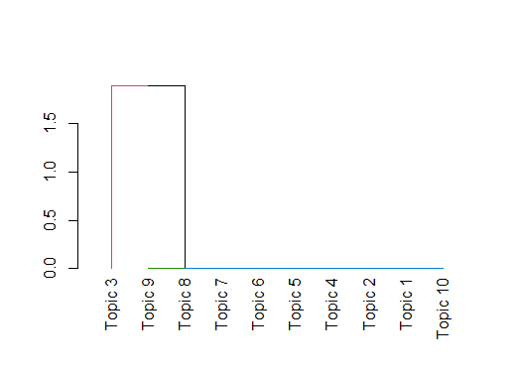

**NLP**

> library(syuzhet)

> aveng <- get_sentences(df_avengers)

> class(aveng)

[1] "character"

**Sentiment analysis**

> sentiments <- c("syuzhet","afinn","bing","nrc","stanford","custom")

> A <- NULL

> sentimentlist <- NULL

>for(i in sentiments[1:4]){

sentimentlist[[i]] <- get_sentiment(aveng,method = i)

A[[i]] <- table(get_sentiment(aveng,method = i))

}

> A

$syuzhet

-2.8 -2.75 -2.5 -2.25 -2.05 -1.9 -1.85 -1.8 -1.75 -1.5 -1.4 -1.35 -1.3 -1.25

1 2 1 1 2 2 1 1 2 4 2 2 2 4

-1.2 -1.15 -1.05 -1 -0.9 -0.8 -0.75 -0.7 -0.6 -0.5 -0.45 -0.4 -0.3 -0.25

2 4 1 11 2 6 15 1 2 17 1 7 2 14

-0.2 -0.15 -0.1 -0.05 0 0.05 0.1 0.15 0.2 0.25 0.3 0.35 0.4 0.5

2 3 1 1 81 4 8 1 4 12 3 3 7 22

0.55 0.6 0.65 0.7 0.75 0.8 0.85 0.9 1 1.05 1.1 1.15 1.25 1.3

5 6 1 3 16 11 3 3 2 1 5 4 10 3

1.35 1.4 1.45 1.5 1.55 1.6 1.65 1.7 1.75 1.85 1.9 2.05 2.1 2.15

5 5 1 6 4 3 2 1 4 3 1 2 1 1

2.25 2.35 2.4 2.5 2.55 2.7 2.75 2.8 3.05 3.1 3.65 3.7 3.75 6.6

1 1 2 1 1 1 1 1 1 1 1 1 2 1

$afinn

-9 -8 -7 -6 -5 -4 -3 -2 -1 0 1 2 3 4 5 6 7 8 9 12 13

1 2 2 1 4 14 21 41 29 133 22 34 26 13 19 9 7 5 4 2 1

14 15

1 1

$bing

-4 -3 -2 -1 0 1 2 3 4 5 8

3 5 22 75 151 85 33 7 9 1 1

$nrc

-4 -3 -2 -1 0 1 2 3 4

1 5 20 56 167 85 42 10 6

> sentiments

[1] "syuzhet" "afinn" "bing" "nrc" "stanford" "custom"

**Plot for NRC**

> plot(sentimentlist$nrc,type = "l",main = "NRC plot",xlab = "Time",ylab = "Emotion")

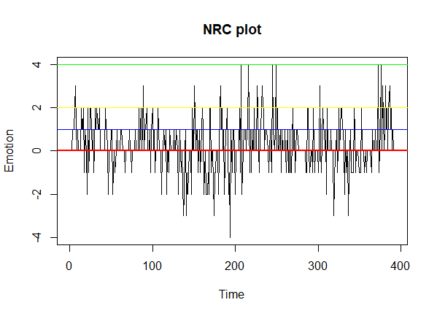

> abline(h=0,col ="red",lwd=2)

> abline(h=1,col ="blue",lwd =1)

> abline(h=2,col ="yellow",lwd=1)

> abline(h=4,col ="green",lwd=1)

**To extract the sentences with most negative emotions**

> negative <- sentimentlist$bing[which.min(sentimentlist$bing)]

> aveng[which(sentimentlist$bing==negative)]

[1] "Having Cap marry Peggy means the pain of his sacrifice, him seeing her in Winter Soldier when she is suffering from Alzheimer's, hell even his blossoming relationship with Sharon Carter is kinda irrelevant."

[2] "Fat alcoholic self pity Thor was not funny and for a demi god he turned out to be league bowler from crap town Ohio."

[3] "In Ironman 2 we find out his dad was distant and cold to him, and in ironman 3 he is getting panic attacks because he thinks it's up to him to save the world from all threats."

**To extract the sentences with most positive emotions**

> positive <- sentimentlist$bing[which.max(sentimentlist$bing)]

> aveng[which(sentimentlist$bing==positive)]

[1] "People are entitled to their own tastes, and the super hero genre of the Marvel variety that is a pastiche of action/adventure, sci-fi, and fantasy doesn't appeal to everyone, but for what it is, for what it succeeds at being for its target audience, Avengers: Endgame is currently the benchmark as a satisfying grand finale in a cinematic universe."

**Percent based fig**

> percentvalues <- get_percentage_values(sentimentlist$bing)

> plot(percentvalues,type = "l",main = "percentage baced means",xlab = "TIME",ylab = "emotion value",col ="blue")

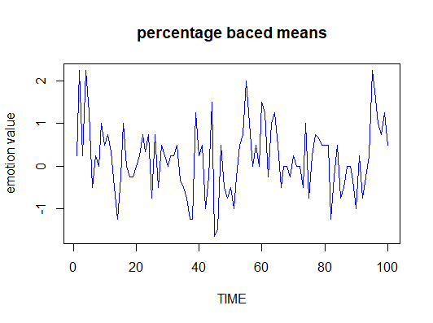

> ft_values <- get_transformed_values(sentimentlist$bing,low_pass_size = 2,x_reverse_len = 100,scale_vals = T,scale_range = F)

> plot(ft_values,col =ifelse(ft_values>0,"red","blue"))

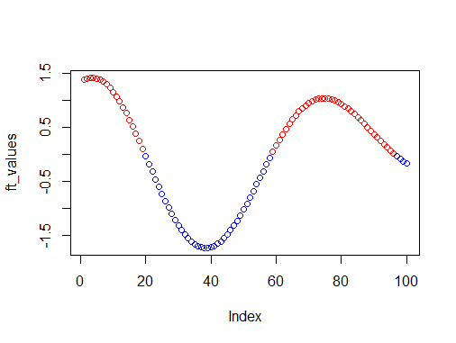

**Emotion plot**

> nrc_data <- get_nrc_sentiment(aveng)

> barplot(sort(colSums(prop.table(nrc_data))),horiz = F,cex.names = 0.8,col = 1:8)

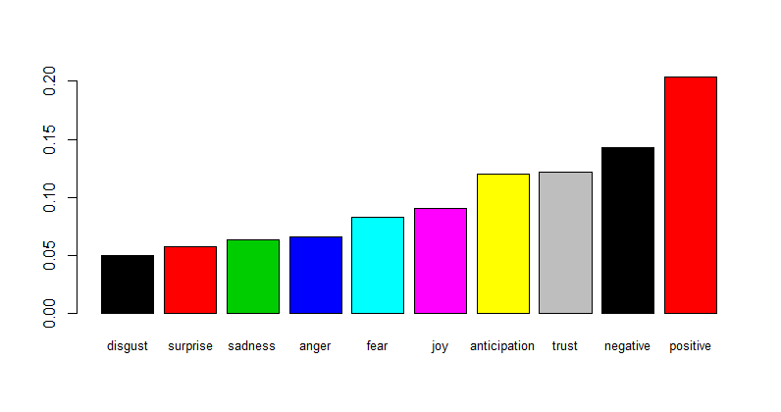

**Word cloud**

> library(tm)

> library(SnowballC)

> library(wordcloud)

> library(RColorBrewer)

> freq <- (rowSums(as.matrix(aveng_tdm)))

> length(freq)

[1] 1555

> ord <- order(freq,decreasing = TRUE)

> head(freq)

about abs absolute accept accomplish acting

21 1 3 1 1 2

> data_frame <- data.frame(word =names(freq),freq= freq)

> windows()

> wordcloud(words = data_frame$word,freq = data_frame$freq,min.freq = 3,max.words = 150,random.order = F,colors = brewer.pal(10,"Dark2"))

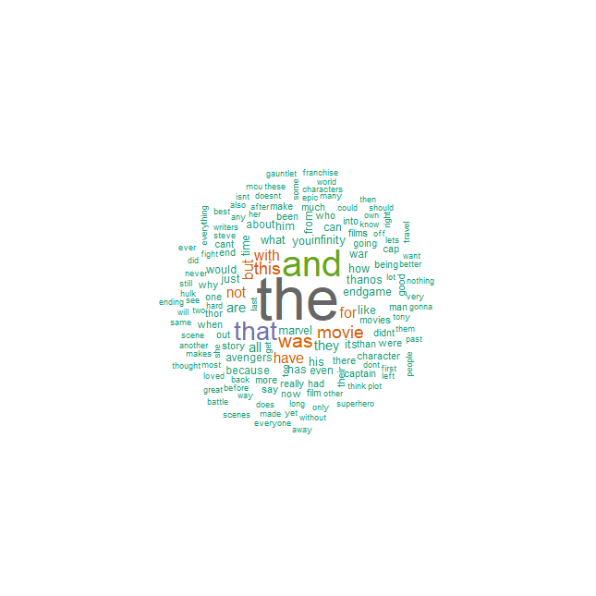

> findFreqTerms(aveng_dtm,lowfreq = 5)

[1] "about" "action" "actually" "after" "all" "also"

[7] "amazing" "america" "and" "any" "are" "avengers"

[13] "back" "because" "been" "before" "best" "big"

[19] "but" "can" "captain" "character" "characters" "could"

[25] "did" "didnt" "dont" "endgame" "ending" "epic"

[31] "even" "ever" "everything" "felt" "fight" "for"

[37] "get" "gonna" "got" "great" "guy" "had"

[43] "have" "hawkeye" "her" "him" "his" "how"

[49] "infinity" "its" "just" "know" "left" "lets"

[55] "like" "line" "long" "love" "man" "many"

[61] "marvel" "more" "most" "movie" "movies" "much"

[67] "not" "now" "own" "past" "peggy" "people"

[73] "perfect" "really" "save" "scene" "see" "she"

[79] "should" "some" "still" "story" "superhero" "than"

[85] "thanos" "that" "the" "them" "there" "these"

[91] "they" "this" "thor" "though" "tony" "too"

[97] "want" "war" "was" "watch" "watching" "way"

[103] "what" "when" "where" "whole" "why" "will"

[109] "with" "world" "years" "you" "another" "around"

[115] "better" "cant" "cap" "change" "defeat" "does"

[121] "doesnt" "end" "everyone" "fan" "first" "franchise"

[127] "from" "game" "gauntlet" "hulk" "into" "iron"

[133] "loved" "made" "make" "never" "new" "off"

[139] "one" "original" "out" "plot" "real" "reviews"

[145] "right" "same" "say" "show" "stones" "stuff"

[151] "sure" "their" "think" "thought" "time" "travel"

[157] "universe" "were" "who" "without" "would" "yet"

[163] "battle" "being" "far" "film" "films" "final"

[169] "getting" "good" "has" "last" "makes" "means"

[175] "only" "other" "scenes" "then" "two" "going"

[181] "again" "audience" "bad" "doing" "guys" "having"

[187] "isnt" "seen" "those" "very" "writers" "away"

[193] "directors" "hard" "mcu" "well" "soldier" "steve"

[199] "super" "nothing" "lot"

> findAssocs(aveng_dtm,terms = "avengers",corlimit = 0.2)

$avengers

forward endgame course are

0.87 0.85 0.85 0.83

story original cinematic appears

0.81 0.81 0.81 0.80

happen important small team

0.80 0.80 0.80 0.80

the above anticipated areas

0.77 0.77 0.77 0.77

center certainly clue comfortably

0.77 0.77 0.77 0.77

comparison concern critical details

0.77 0.77 0.77 0.77

disappearedon discussed distress divided

0.77 0.77 0.77 0.77

drags errors everyones expectation

0.77 0.77 0.77 0.77

familyof fore front general

0.77 0.77 0.77 0.77

heavy higher highlights homage

0.77 0.77 0.77 0.77

included insignificant legend logic

0.77 0.77 0.77 0.77

meaningful meaningless moreover moves

0.77 0.77 0.77 0.77

necessary normally outside overshadowed

0.77 0.77 0.77 0.77

packed partsavengers period play

0.77 0.77 0.77 0.77

pointlastly predicament probability realize

0.77 0.77 0.77 0.77

recent rising role separate

0.77 0.77 0.77 0.77

slight slower stage stories

0.77 0.77 0.77 0.77

struggle surprise tempo tenyear

0.77 0.77 0.77 0.77

terms theories threehour turn

0.77 0.77 0.77 0.77

undoubtedly visual waited wonder

0.77 0.77 0.77 0.77

wondered scene our two

0.77 0.76 0.76 0.76

comes aspects finale shouldnt

0.75 0.73 0.73 0.73

after marvel there heroes

0.72 0.72 0.71 0.71

successful about fully put

0.71 0.69 0.69 0.69

rest last other find

0.69 0.68 0.68 0.67

home minutes would battle

0.67 0.67 0.66 0.66

good infinity need goes

0.65 0.64 0.63 0.63

history universe widow become

0.63 0.63 0.63 0.63

action you can more

0.61 0.61 0.60 0.60

war being has character

0.60 0.60 0.60 0.59

this beginning head all

0.59 0.59 0.59 0.58

message most these whatever

0.58 0.58 0.58 0.58

marvels have certain final

0.58 0.57 0.57 0.57

spiderman work for scenes

0.57 0.57 0.56 0.56

been great hero makes

0.55 0.55 0.55 0.55

getting and captain think

0.54 0.53 0.53 0.53

means not world who

0.53 0.52 0.52 0.52

example film man hand

0.52 0.52 0.51 0.51

one disappointment effects events

0.51 0.51 0.51 0.51

future lee related stan

0.51 0.51 0.51 0.51

youre building else focus

0.51 0.51 0.51 0.51

holes open punch seem

0.51 0.51 0.51 0.51

set together towards many

0.51 0.51 0.51 0.50

thor cant expecting but

0.50 0.50 0.50 0.49

directors fight far himself

0.49 0.48 0.48 0.48

mjolnir strange wakanda lets

0.48 0.48 0.48 0.47

gauntlet films which what

0.47 0.47 0.47 0.46

seems big characters emotional

0.46 0.45 0.45 0.45

happy his strong win

0.45 0.45 0.45 0.45

case how them then

0.45 0.44 0.44 0.44

everything heroic reaching same

0.43 0.43 0.43 0.42

anything because that doesnt

0.42 0.41 0.41 0.41

end writers did much

0.41 0.41 0.40 0.40

some than thanos from

0.40 0.40 0.40 0.40

only even full gives

0.40 0.39 0.39 0.39

powerful was biggest fast

0.39 0.39 0.39 0.39

hasnt always development satisfying

0.39 0.39 0.39 0.39

just another someone going

0.38 0.38 0.38 0.38

stones dont finally had

0.37 0.35 0.35 0.35

life out admiration admirationrespect

0.35 0.35 0.35 0.35

against airbut antics appearing

0.35 0.35 0.35 0.35

arrives assumed attention avenging

0.35 0.35 0.35 0.35

battling begins bludgeon both

0.35 0.35 0.35 0.35

break butt camera capt

0.35 0.35 0.35 0.35

child choke choreographed click

0.35 0.35 0.35 0.35

clip combatants commenting complement

0.35 0.35 0.35 0.35

complicated contend corrupted creation

0.35 0.35 0.35 0.35

credible dangerous defeatable deliberately

0.35 0.35 0.35 0.35

demands destroy discarded dominant

0.35 0.35 0.35 0.35

drinking driven earned earnt

0.35 0.35 0.35 0.35

easy embarrassing engagement entrance

0.35 0.35 0.35 0.35

established female flashing foe

0.35 0.35 0.35 0.35

fool former frustrations fuelled

0.35 0.35 0.35 0.35

geography gimmicky grabs ground

0.35 0.35 0.35 0.35

guardians guysand half henchman

0.35 0.35 0.35 0.35

heroismlikewise himits holding humiliation

0.35 0.35 0.35 0.35

iconic identified incredible initially

0.35 0.35 0.35 0.35

intuitively journey kicks lights

0.35 0.35 0.35 0.35

likewise lines maintained manifest

0.35 0.35 0.35 0.35

massed massive minded motivated

0.35 0.35 0.35 0.35

obviously onin peoplein place

0.35 0.35 0.35 0.35

pointlessthe possession pot power

0.35 0.35 0.35 0.35

powered preparing primordial pssed

0.35 0.35 0.35 0.35

pull punches pyrotechnics question

0.35 0.35 0.35 0.35

rage ranks realise recognised

0.35 0.35 0.35 0.35

reek relatable remaining removed

0.35 0.35 0.35 0.35

rescue revengeto reversing ridiculing

0.35 0.35 0.35 0.35

roll rules running seemingly

0.35 0.35 0.35 0.35

selfthe senseiw sensitive sexy

0.35 0.35 0.35 0.35

shadow showcases shows silly

0.35 0.35 0.35 0.35

smash smashes smashing somehow

0.35 0.35 0.35 0.35

stakes standing station stoic

0.35 0.35 0.35 0.35

stonesyet stormbreaker takes talking

0.35 0.35 0.35 0.35

tension theme throw thrown

0.35 0.35 0.35 0.35

titan train unbeatable understood

0.35 0.35 0.35 0.35

undo used vengeful weapon

0.35 0.35 0.35 0.35

whether whose wielding wings

0.35 0.35 0.35 0.35

wonderfully workthe actual aim

0.35 0.35 0.35 0.35

aimed aou arc arcs

0.35 0.35 0.35 0.35

assasination assassin associated attack

0.35 0.35 0.35 0.35

attacks becoming believes boggles

0.35 0.35 0.35 0.35

brain breaker calls check

0.35 0.35 0.35 0.35

clear cold commits compass

0.35 0.35 0.35 0.35

conclusion dad die disconnected

0.35 0.35 0.35 0.35

dissapointing distant doctor drop

0.35 0.35 0.35 0.35

dying except facility filmed

0.35 0.35 0.35 0.35

fit fizzles fly friend

0.35 0.35 0.35 0.35

gets gotten headed huge

0.35 0.35 0.35 0.35

husband ignore ignored importance

0.35 0.35 0.35 0.35

inconsistent instead ironman knocked

0.35 0.35 0.35 0.35

leading learned let list

0.35 0.35 0.35 0.35

live lost married mind

0.35 0.35 0.35 0.35

moving niece panic personal

0.35 0.35 0.35 0.35

picking plan planet portal

0.35 0.35 0.35 0.35

powers proven ran random

0.35 0.35 0.35 0.35

retire rogers saving says

0.35 0.35 0.35 0.35

seemed setting situation snap

0.35 0.35 0.35 0.35

soon spaceship steves stopping

0.35 0.35 0.35 0.35

storm storyline stranges suffered

0.35 0.35 0.35 0.35

supposed terrific things thousands

0.35 0.35 0.35 0.35

till tragedy tried use

0.35 0.35 0.35 0.35

washed wheres won wrong

0.35 0.35 0.35 0.35

youd peggy with yet

0.35 0.34 0.34 0.34

fights looked face tony

0.34 0.34 0.33 0.33

when black never say

0.33 0.33 0.33 0.33

well save why couldnt

0.33 0.32 0.32 0.32

defeat right thats manage

0.32 0.32 0.32 0.32

scarlet witch down funny

0.32 0.32 0.32 0.32

take bucky steve tonys

0.32 0.32 0.32 0.32

point also him they

0.32 0.31 0.31 0.31

able sacrifice back watching

0.31 0.31 0.30 0.30

years everyone into mcu

0.30 0.30 0.30 0.30

america father loss matter

0.29 0.29 0.29 0.29

might really remember thinking

0.29 0.29 0.29 0.29

found here hulk guys

0.29 0.29 0.29 0.29

start away coming desire

0.29 0.29 0.29 0.29

feels given south friends

0.29 0.29 0.29 0.29

threats whats works parents

0.29 0.29 0.29 0.29

its own should way

0.27 0.27 0.27 0.27

better make nothing ending

0.27 0.27 0.27 0.26

ever taking plot their

0.26 0.26 0.26 0.26

amazing hawkeye almost iron

0.25 0.25 0.25 0.25

arent doing look sense

0.25 0.25 0.25 0.25

actionadventure allegorical appeal archetypal

0.25 0.25 0.25 0.25

attempt barrier benchmark camaraderie

0.25 0.25 0.25 0.25

cast casual chemistryno combination

0.25 0.25 0.25 0.25

commentary comparing conflict constantly

0.25 0.25 0.25 0.25

current currently dark daythat

0.25 0.25 0.25 0.25

dcus detract different doubt

0.25 0.25 0.25 0.25

dramathe element elements embody

0.25 0.25 0.25 0.25

entitled entry especially exactly

0.25 0.25 0.25 0.25

fantasy fatigue franchises fuse

0.25 0.25 0.25 0.25

genre genres glossed grand

0.25 0.25 0.25 0.25

grasp heroism ill inarticulate

0.25 0.25 0.25 0.25

investment itthe jokes justice

0.25 0.25 0.25 0.25

knight land lead loopholes

0.25 0.25 0.25 0.25

markus masterpiece masterpieces matrix

0.25 0.25 0.25 0.25

mcfeely mindexpanding minoradmittedly mystical

0.25 0.25 0.25 0.25

night nitpicky nor observations

0.25 0.25 0.25 0.25

opinionspeople oversaturation parts pastiche

0.25 0.25 0.25 0.25

piece plays popentertainment profound

0.25 0.25 0.25 0.25

required requires rubes rushed

0.25 0.25 0.25 0.25

scifi skillfully spectacle stephen

0.25 0.25 0.25 0.25

struggles succeeds target tastes

0.25 0.25 0.25 0.25

troll understands unique universethere

0.25 0.25 0.25 0.25

variety viewer were isnt

0.25 0.25 0.23 0.23

see epic like movies

0.22 0.21 0.21 0.21

changing creates entire inconsistencies

0.21 0.21 0.21 0.21

single stuff ive knew

0.21 0.21 0.21 0.21

linearity post threat falcon

0.21 0.21 0.21 0.21

part shield becomes decided

0.21 0.21 0.21 0.21

starts thinks talk tell

0.21 0.21 0.21 0.21

deliver each galaxy affect

0.21 0.21 0.21 0.21

looking cgi forget give

0.21 0.20 0.20 0.20

honest killed showed told

0.20 0.20 0.20 0.20

probably theyre least invested

0.20 0.20 0.20 0.20

star

0.20

> head(data_frame,10)

word freq

about about 21

abs abs 1

absolute absolute 3

accept accept 1

accomplish accomplish 1

acting acting 2

action action 5

actually actually 5

after after 12

alerteven alerteven 1

>barplot(data_frame[1:10,]$freq,names.arg = data_frame[1:10,]$word,col = "navyblue")

